REVIEW 3
I. Circle the odd one out.
A | B | C | D
0. socks | dad | sister | brother
1.orange | apple | red | yellow
2.kitchen | bathroom | bedroom | tomato
3.tomato | drinks | dress | sandwich
4.T-shirt | apartment | pants | hat
5.banana | bird | cat | dog
6.cookie | drinks | bath | sandwich
7.eight | ten | three | teeth
8.pear | pen | pencil | eraser

II. Write.
four | They’re | don’t | Where’s | a an | She’s | have | an an a | and | Where are

- _____________Rosy ? => _________ in the kitchen.
_____________ Grandma and Grandpa ? => _______________ in the living room.
- I __________ a sandwich.
- I _________ have a banana.
- I have _____ pear.
- I have _____ apple.
- I have _____ egg.
- I have _____ orange.
- I have _____ tomato.
- I have ________ sandwiches.
- I have a cheese _________ tomato sandwich.

III. Write a or an.

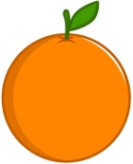 | 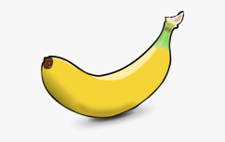 | 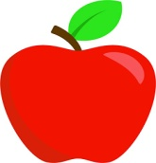 | 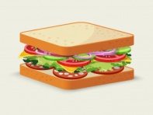
_____ orange | _____ banana | _____ apple | _____ sandwich
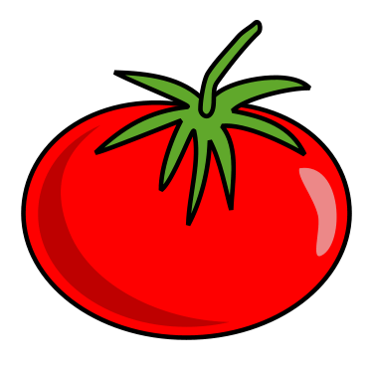 | 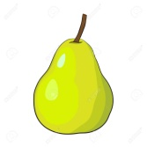 | 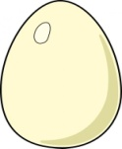 | 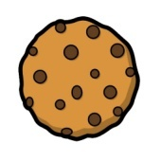
_____ tomato | _____ pear | ______ egg | _____ cookie

IV. Write I have / I don’t have
1. 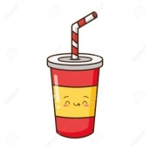 | _________________________ a drink.
2. | _________________________ a cookie.
3. | _________________________ a sandwich.
4. | _________________________ a tomato.
5. | _________________________ an egg.
6. | _________________________ a pear.
7. 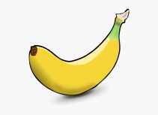 | _________________________ a banana.
8. | _________________________ an apple.
9. 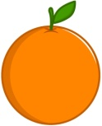 | _________________________ an orange.
10. 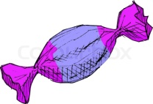 | _________________________ a candy.

V. Unscramble the words.
1. | rehte | - ______________________________________
2. | mootat | - ______________________________________
3. | tabh | - ______________________________________
4. | reap | - ______________________________________
5. | hette | - ______________________________________
6. | sagrep | - ______________________________________
7. | bbay | - ______________________________________
8. | tonuc | - ______________________________________
9. | resah | - ______________________________________
10. | secehe | - ______________________________________
11. | ratwe | - ______________________________________
12. | oiekoc | - ______________________________________
13. | nnaaab | - ______________________________________
14. | sinkrd | - ______________________________________
15. | chidaswn | - ______________________________________
16. | nuxoblhc | - ______________________________________
17. | mitechunl | - ______________________________________
18. | seocho | - ______________________________________
19. | kicch | - ______________________________________
20. | cheerat | - ______________________________________
21. | raich | - ______________________________________
22. | teltil | - ______________________________________
23. | pirch | - ______________________________________
24. | supraits | - ______________________________________
25. | sriatsnwod | - ______________________________________
26. | tenmatarp | - ______________________________________
27. | sohue | - ______________________________________
28. | morobde | - ______________________________________
29. | neitckh | - ______________________________________
30. | bamrooht | - ______________________________________

- Look and write
- 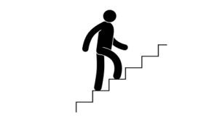  __________________ | - 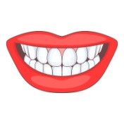  _____________________ | 3. 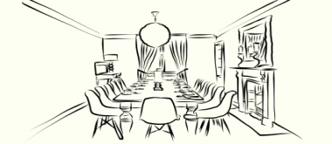  _______________________
4. 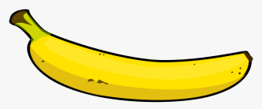  ____________________ | 5. 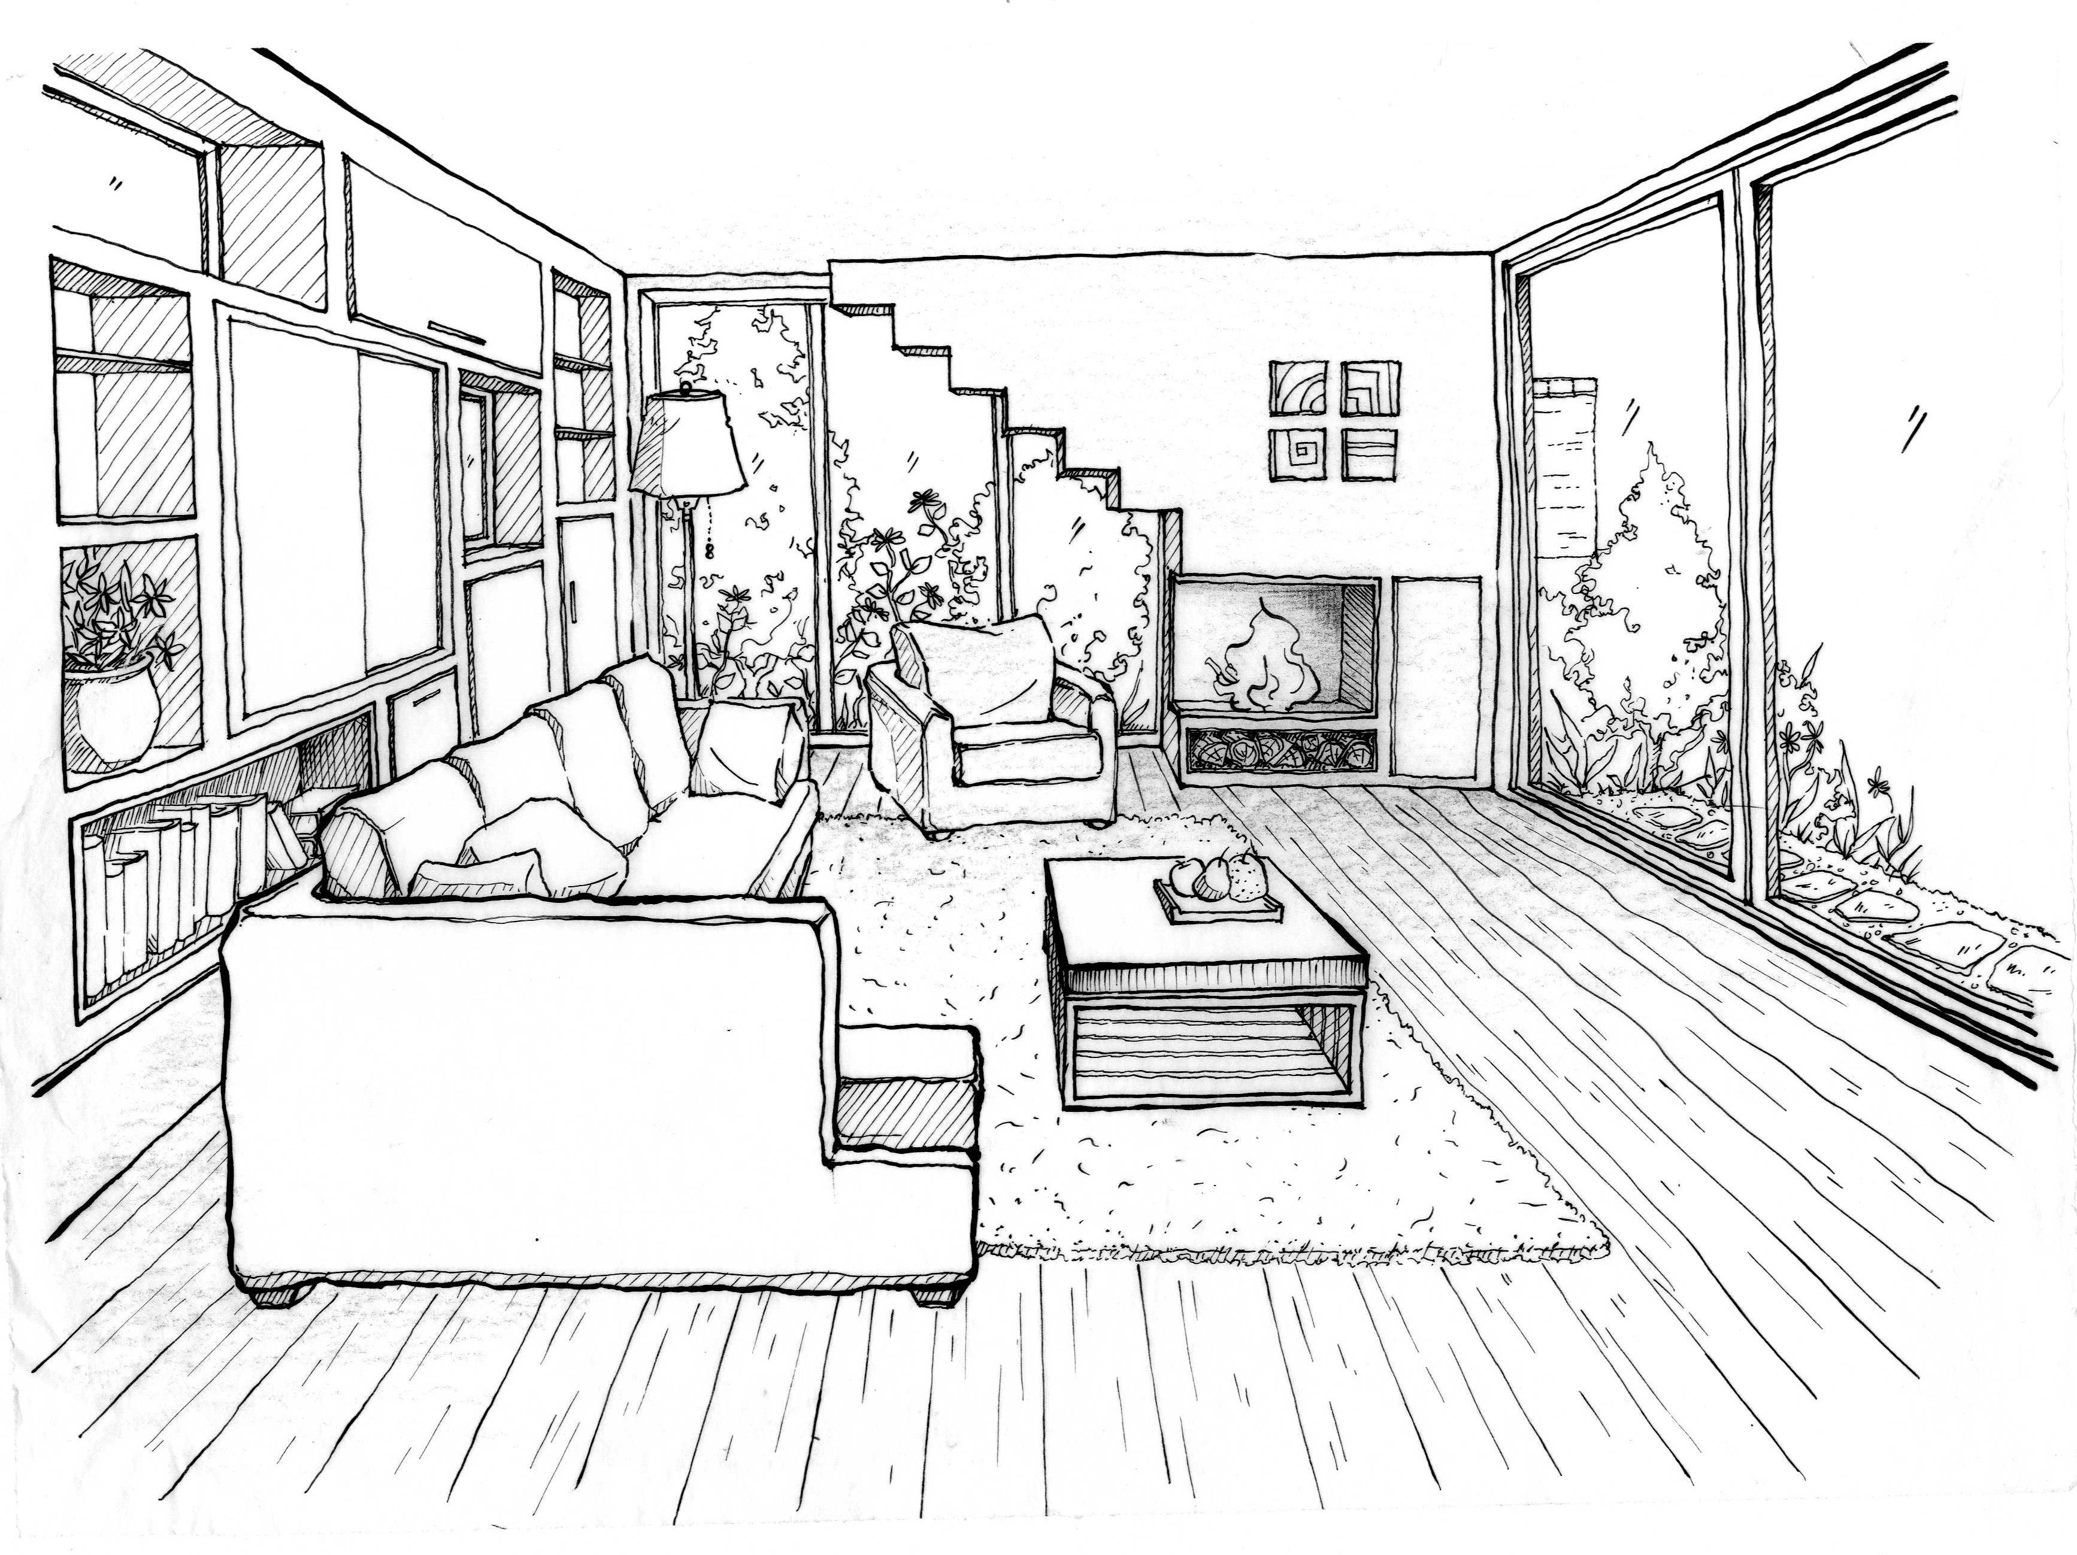  _______________________ | 6. 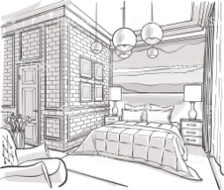  _____________________
7. 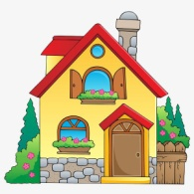  ______________________ | 8.  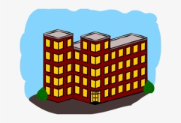  _________________ | 9. 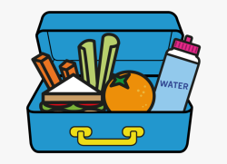  ______________________
10.  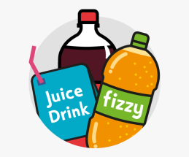  ____________________ | 11.  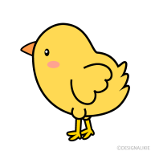_____________________ | 12. 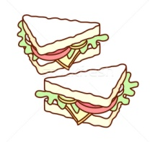____________________________  ____________________
13. 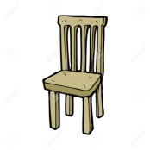  _______________ | 14. 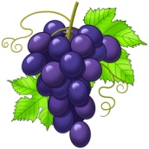  ________________ | 15. 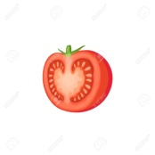  ________________
16. 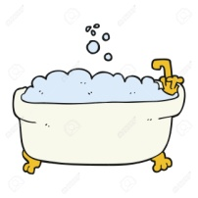  ______________________ | 17. 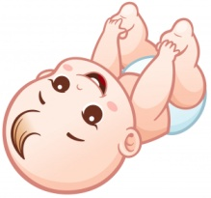  __________________ | 18. 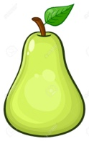  ______________________
The end!

