REVIEW
- write
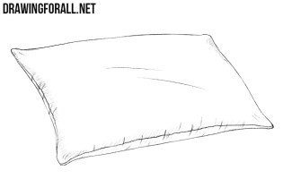  ………………….. |   ……………… | 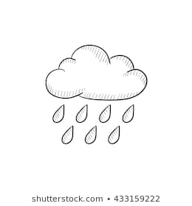  …………….. | 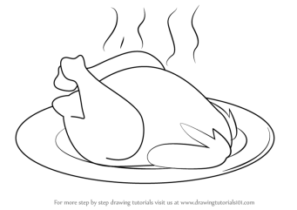  ……………….
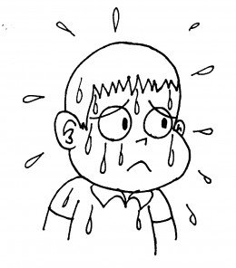  …………………… | 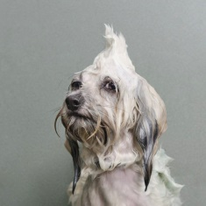  ………………….. | 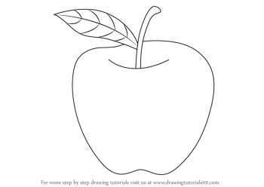  ………………. | 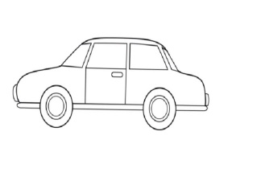  ………………..
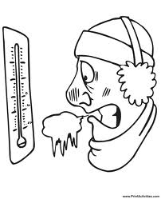  …………………… |   …………………. | 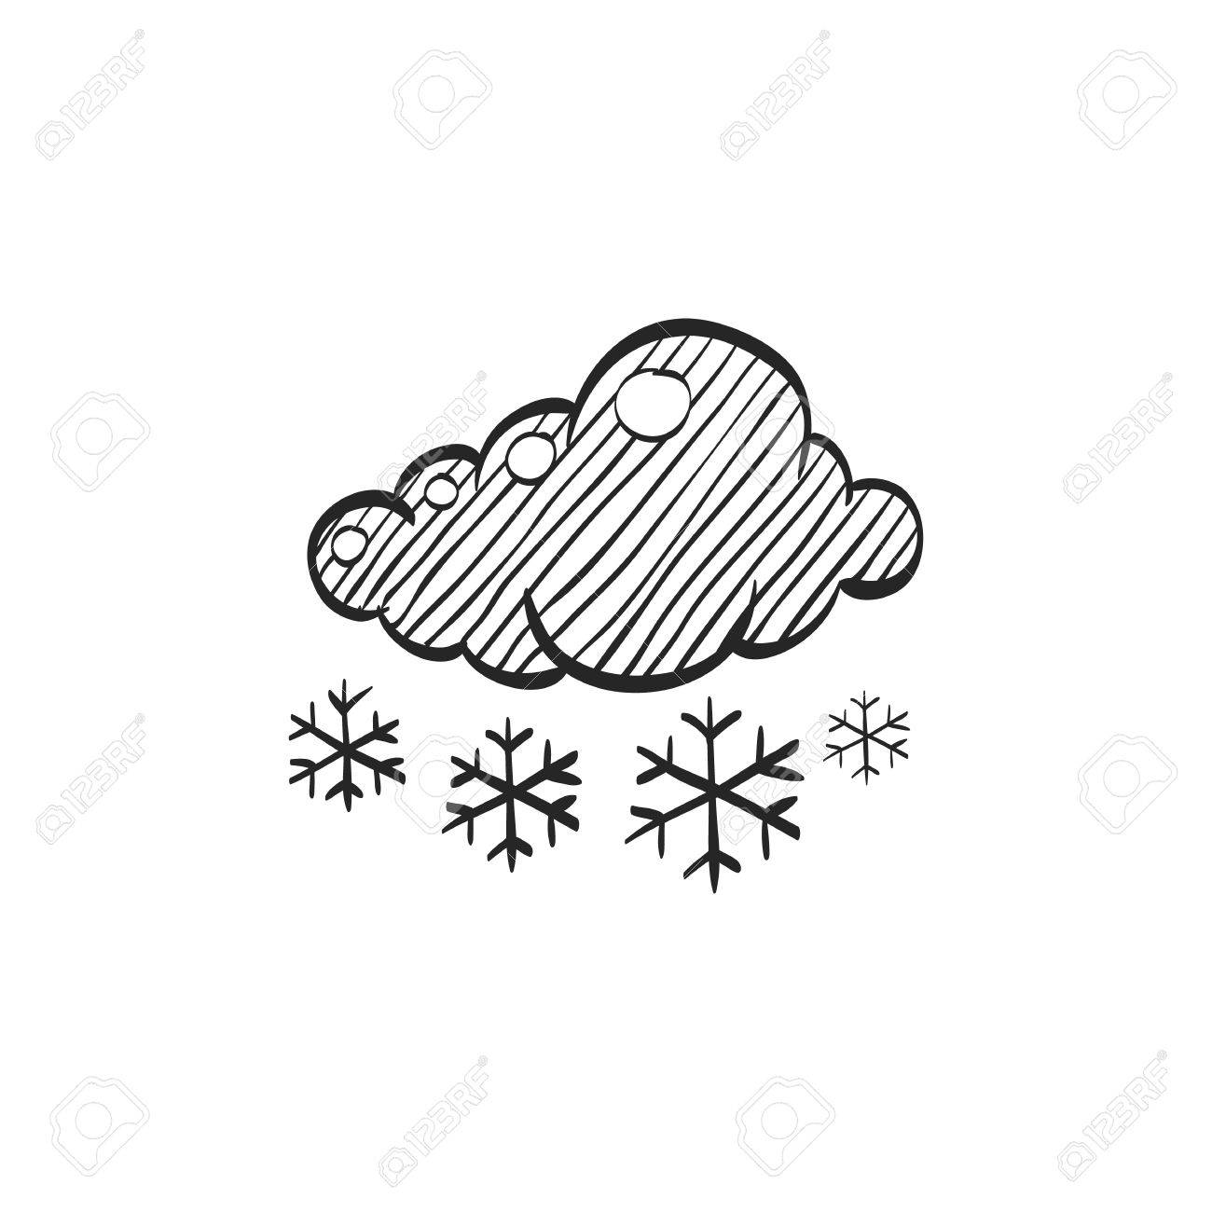  …………………. | 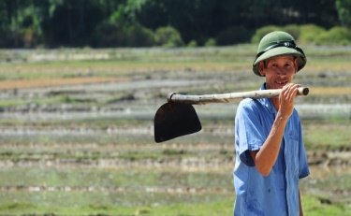  …………………
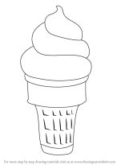  ………………….. | 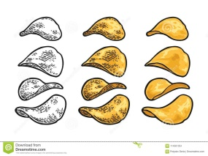  ………………… | 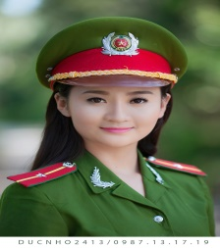  ……………… | 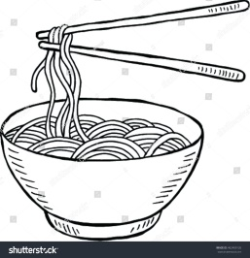  …………………….
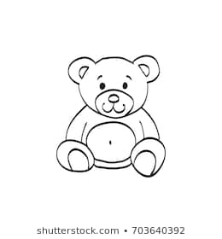  ………………….. | 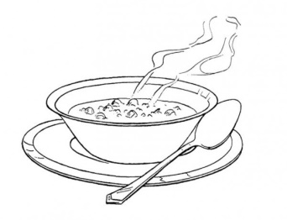  …………… | 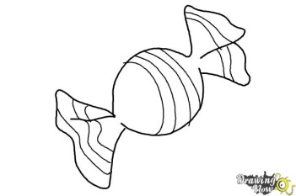  …………………….. | 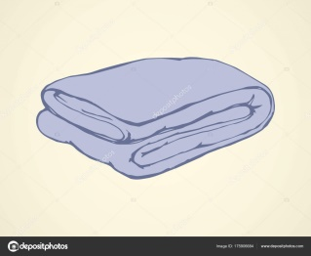  ………………….

II.Odd one out.
- a. swing b. slide c. run d. puppet
- a. weather b. snowing c. sunny d. raining
- a. police officer b. farmer c. bear d. teacher
- a. wet b. hurry up c. wet d. cold
- a.noodles b. ice cream c. soup d. chicken
- a.pillow b. blanket c.bear d. book
- a. one b. five c. bus d. two
- a. yellow b. green c. purple d. good
III.Complete. ( want be stop green not It’s have raining bear is hot my)
- Red light. ___________!
- _______light. Go!
- I’m hungry. ____ some soup.
- Hurry up. It’s____________.
- _____ sunny. I’m _____.
- That’s my ________.
No! It’s ______ bear.
- She___ a farmer.
- Shh! ___ quiet!
- I _________ candy.
No. ______today.
IV. Answer the question.
- What’s your name?
………………………………
- How are you?
…………………………….
GOOD LUCK

