TEST OF ENGLISH FOR THE FOUFTH GRADERS

I/ Look and write :

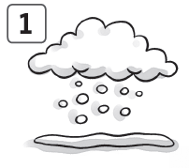  ___________________ | 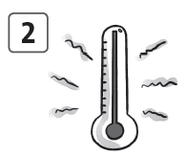  ____________________ |   ___________________
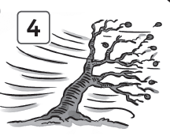  ___________________ | 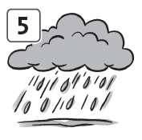  __________________ | 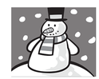  6  __________________

II/ Circle and correct :
- play a kite fly a kite

- do a snowman ______________________
- go on your hat _______________________
- fly outside __________________________
- put a bike ___________________________
- make football ________________________
- eat milk ____________________________
- count a picture ______________________
- put in your coat ______________________
- put on wet __________________________

III / Read and guess the answer. Circle A, B or C :
- It’s cold and white. It comes from sky . What is it ?
- It’s snow. B. It’s the sun. C. It’s the moon.

- Let’s go to the park and fly our kite. It can fly high today. What’s the weather like?
- It’s cold. B. It’s windy. C. It’s snowing.

- Put on your raincoat and your hat. Don’t forget your umbrella. What’s the weather like?
- It’s raining. B. It’s sunny. C. It’s windy.

- I love this weather. We can play outside and go to the park. I like playing soccer and riding my bike. I like the pool in this weather , too. Sometimes my mom buys ice-cream and cold drinks. What’s the weather like ?
- It’s cold and snowing.
- It’s raining and windy.
- It’s hot and sunny.

IV/ Read sentence and find verb (v) , adjectives (adj) :
- I have a red umbrella.
(v) (adj)

- Rosy’s mother works at the big hospital.

- Fred is a blue and yellow parrot.

- I like an orange slippers.

- He doesn’t like small cake.

- I have a cold ice cream.

V/ Unscramble and write :
1/ is what it time ?
_______________________________________________________
2/ Billy home at go two doesn’t o’clock .
_______________________________________________________
3/ hot is Monday the on weather .
_______________________________________________________
4/ not we umbrellas have do our .
________________________________________________________
5/ home lunch with has at mom she and dad her .
_________________________________________________________
6/ father at works my in airport the night .
_________________________________________________________

VI/ Look at the picture and answer the question :

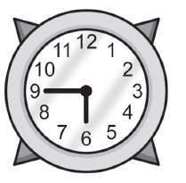 | 1/ What time is it ?  _____________________________________
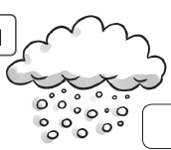 | 2/ What’s the weather like ?  ________________________________________
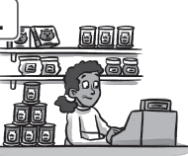 | 3/ Where does she work ?  _____________________________________
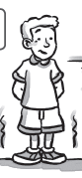 | 4/ What is he wearing ?  _____________________________________

