School : …………………….. TEST
Score
Class : ……………….. Date : ……………………
Name : …………………………
I/ Unscramble and write :
- u / s / u : _______________ | 4. p / e / t/ p / u /p : _________________
- o / k / b/ o : ____________ | 5. u / m / p / j : ____________________
- o / n / d / w : ___________ | 6. l / o / h / l /e : ___________________
II/ Match :

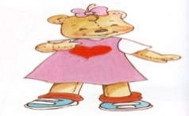 | - I’m a girl. | 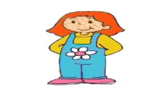
 | - I’m a teacher.  - A book. | 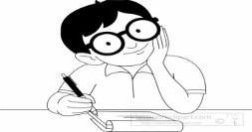
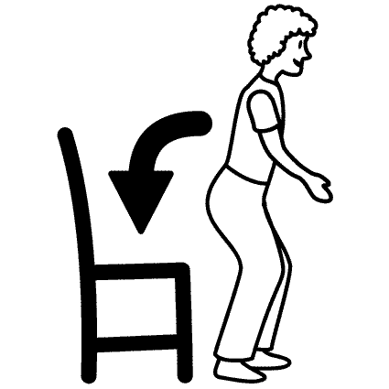 | - I’m Benny.  - I’m Miss Dolly. | 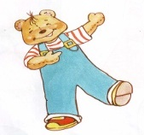
 | - I’m a boy.  - A puppet. | 
 | - Jump !  - Hi ! My name’s Kitty. | 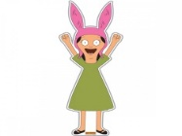
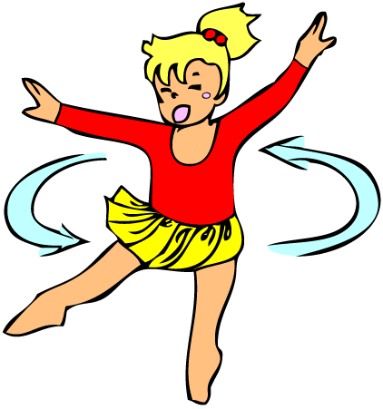 | - Up !  - I’m Sue. | 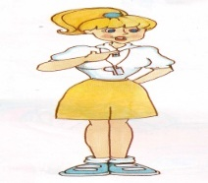
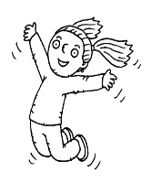 | - A crayon.  - Down! | 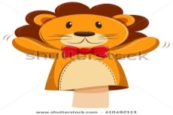
 | - Turn around !
III/ Complete the dialogue :
Thank girl Fine Good morning ‘s
Hi sorry My up teacher

1/ __________ you.  You’re welcome. | 5/ _______ name’s Kitty.
2/ Good morning, Benny.  ______________, Miss Dolly. | 6/ Good morning, Sue.  My name_____ Benny.
3/ Hello, Panda. How are you ?  _________. Thank you. | 7/ Hello. I’m a ______________ .  Hello teacher. I’m a ___________ .
4/ Ouch !  I’m ________________ . | 8/ __________ ! I’m Benny.

IV/ Find and circle :
teacher puppet book down jump welcome boy

H | T | G | V | J | L | F | H | P | G | D
J | E | N | C | U | S | W | Q | U | F | O
O | A | M | L | M | F | B | R | P | S | W
Q | C | E | P | P | R | C | N | P | D | N
R | H | W | T | U | E | V | B | E | P | J
W | E | L | C | O | M | E | D | T | H | E
Y | R | R | H | H | W | R | Z | O | J | G
B | O | Y | J | K | I | Y | B | O | O | K

